|  |  |
| --- | --- |
| **Student Name:** | **Li, Yingzao <yingzao.li@rbc.com> also known as Kiera** |
| **Nominator(s):** | **Michael Chiang – Scrum Master + Sr. App Specialist** |
| **Student’s Position Title:** | **Developer** |
| **RBC Business Unit Name:** | **Digital Client Experience (Technology & Operations)** |

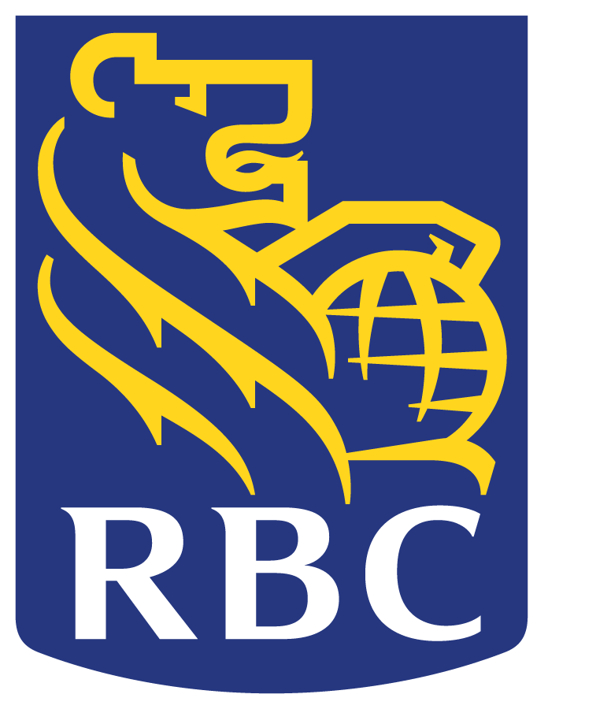

Student of the Term Award Nomination Form

* For each of the following capabilities, please input 2-3 points supporting your student’s contributions.
* The winner will be determined based not only on the examples you outline but on the testimonials provided as well.
* Tip: Providing *specific* situations or examples will help strengthen your nomination!

|  |  |
| --- | --- |
| **Key Capabilities:** | **Actions Taken** |
| **PERFORMANCE**   * Ambitious/Motivated/Eager * Creative/Innovative * Energetic * Work ethic * High quality work * Display of professionalism * Uphold RBC reputation * Positive impact to team, colleagues, and leaders | |  |  | | --- | --- | | Ambitious/Motivated/Eager | * Always the 1st to volunteer to tackle new challenges. * If she doesn’t know something she will take time to learn/solve it herself and timebox herself to ask for assistance if required. 9 out of 10 times she figures it out. | | Creative/Innovative | * Thinks outside of the box when solving problems. * Utilizes existing frameworks and adds her twist to simplify code improving processing efficiency. | | Energetic | * Her big smile and enthusiasm with a big fist pump always let us know that she’s done something extraordinary. The team is so accustomed to this that we expect big things from her. | | Work ethic | * She is the consummate professional. Always wanting to learn and always maintaining good relationships within various teams where everyone is always delighted to assist when she asks for help. * She is never the first to leave the office. She typically works past the regular FTE working hours preferring to stay with the team until everyone is ready to leave for the night. * She seeks input for her work and for her ideas. She never complains and always takes feedback as constructive criticism. | | High quality work | * There are never any complaints of her work during code reviews. * If there are any concerns or suggestions she takes the feedback and improves on the code that she has produced. * Her code is top-notch and can be considered like a FTE’s coding effort. | | Display of professionalism | * She shows up to work every day with a positive attitude and knows exactly what she will be doing for the day. * She asks for opinions, ideas, comments, etc. when she feels she would like feedback. | | Uphold RBC reputation | * She meets every characteristic described in One RBC. * She represents RBC well in the office and with her co-op peers. | | Positive impact to team, colleagues, and leaders | * Kiera is respected by her peers in the team lab. * Kiera is equally respected and admired by senior managers and directors for her technical contribution but also her “soft” qualities that many people take years to develop in the workplace. * She is not considered a “co-op” student. She is one of the team and is treated exactly like an FTE because she is an equal and performs daily as an equal to all team members. | |

| **RBC Values** | **How was this RBC value demonstrated?** |
| --- | --- |
| **SERVICE**  *We provide excellent service to clients and each other.*   * Build strong and enduring client relationships * Seek to understand what RBC clients need and offer advice and solutions that are right for them * Be known as an organization that cares about people, is approachable and delivers excellent value | * Kiera is respected by the Glass project’s product owners (i.e. the business), Glass project team members and the Digital Client Experience group. * The product owners are especially thrilled with Kiera as they know the work that she does provides value to the business. She is praised regularly via email, phone conferences and project reviews. * She has quickly caught up to the business value of the Glass project and is trusted by the product owners (i.e. the business) to provide them with advice and options when the product owners require technical guidance (e.g. can we technically do this?). |
| **TEAMWORK**  *We believe in each other and work together to succeed.*   * Have confidence and trust in the capabilities and intentions of our colleagues across RBC * Share knowledge and learn from each other * Focus on doing what’s best for RBC clients and the organization | * Kiera works well independently and is equally strong as a team player. She is respected by the Glass project’s team members as an equal because her contributions as a technical resource far exceeds what is expected from her but also from her natural personality that shines every day making it a pleasure and joy to work with her. * If Kiera doesn’t know something she has no problem asking. And when she figures something out that she didn’t know before she would explain her thought process and the value of what she did to the project team for them to learn. |
| **RESPONSIBILITY**  *We take personal responsibility for high performance.*   * Knowing we each can make a difference, take personal responsibility for our own results and those of RBC * Always reach higher, go farther and achieve more than our competitors | * Kiera understands the importance of the Glass project and the business value it brings. * She works tirelessly to ensure that the work she does is perfect for production release. * She never wants to stop learning and is always reaching to that next level whether it be technical skills or soft skills. * She is always the first to volunteer to provide assistance whether it be learning new skills that will be implemented during the project or when another team member asks for help. She always takes the initiative to always be involved and help the team in any way possible. |

**TESTIMONIALS:**

|  |
| --- |
| The Glass team has been blessed with Kiera as our co-op student. We watched Kiera blossom from the very start from someone who openly acknowledged that she hasn’t coded with the coding language that the team was working with to a full package developer who could perform just as well or better than an established developer.  Personally, I find that Kiera’s best trait is her humility. Kiera is always learning and taking feedback and turning it into action items for herself to become better technical developer every day but also growing her soft skills that are essential in today’s work environment. For the things that Kiera’s does know, and others do not, Kiera takes the time to patiently teach and mentor other team members. She never takes the spotlight and always has the mentality of “I succeed when the team succeeds”. This is an impressive mentality for someone so young in their career (a co-op student!) to understand that a single person does not define a team or a project’s success. It is the combined efforts of the team that makes the project a success. Bravo Kiera for understanding that this at such an early stage of her working career in the fast-paced world of software development.  There are many examples of the excellence that Kiera brings as an integrated member of our RBC Digital Client Experience team for the Glass/Simplified desktop application project. The following examples of Kiera’s achievements for our team includes but are not limited to:   * Understanding and applying complex business requirements into tangible software that is key to the user experience and provide increased business value. * Taking on a work (i.e. myData reports) that was estimated by a full-time resource to take at least 4 weeks. Kiera produced working code within 8 days. This is approximately ***60% savings of day-to-day effort*** that translates into significant time improvements and cost reductions if this work was completed by an FTE. It isn’t because the work estimate was incorrect, but it was because Kiera took the time to understand the business value of the work and then she proceeded to simplify and improve on her code in an iterative manner which resulted in the myData reports rendering quicker to the end user. * Ability to quickly learn existing code from downstream applications and provide feedback to the product owners (i.e. the business) during forensic data analysis. ***Our product owner Chris Everill has praised Kiera many times*** and especially when Kiera discovers data inconsistencies with integration data. Forensic data analysis is not an easy task and Kiera took on this responsibility and handled it like a veteran developer. * Volunteering to take on new challenges that requires research and learning outside of regular office hours, so it can be applied to the project. * Taking constructive criticism to always learn and improve her coding techniques to ensure clean and consistent code. * Growing more comfortable in providing technical leadership to other team members.   Typically, large organizations (e.g. Facebook, Amazon, Microsoft, etc.) recruit students before they graduate from their post-secondary studies. RBC should be at the front of the line and be prepared to woo Kiera to the benefits and advantages of beginning her full-time career at RBC. The reason I state this is because I am 100% certain that Kiera will be one of the most sought-after talents when she graduates from the University of Waterloo because of her technical, business and soft skills that will be in extremely high demand.  Kiera is a talented developer and an even better person. Her professionalism is rare nowadays and her bright and cheerful personality is welcomed every day and she will be sorely missed. We all wish her the very best in her studies and future adventures. |

**Thank you for nominating a student! Please submit your form by April 12, 2019 to** [**earlytalent@rbc.com**](mailto:earlytalent@rbc.com)**.**